1. Assume each salesperson has a 12% commission. Write a query on the orders table that will produce the order number, the salesperson number, and the amount of the salesperson’s commission for that order.

ANS:

KD4-89208-Ashish>select Onum,Snum,amt*0.12 as Comission_amt from orders;

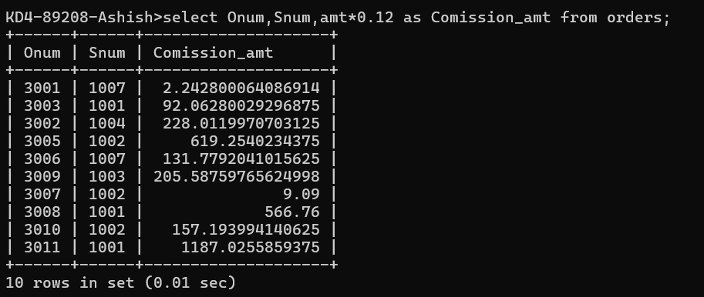

1. Write a query on the Customers table that will find the highest rating in each city. Put the output in this form:

ANS:

KD4-89208-Ashish>select concat(concat('For the city ',city),concat('the highest rating :',max(rating)))

-> as output

-> from customers group by city;

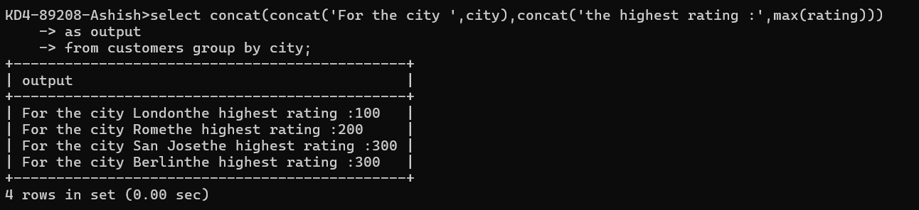

1. Write a query that lists customers in descending order of rating. Output the rating field first, followed by the customer’s name and number.

ANS :

KD4-89208-Ashish>SELECT rating, Cname, Snum

-> FROM customers

-> ORDER BY rating DESC;

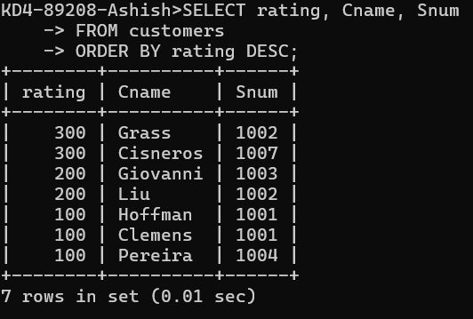

1. Write a query that totals the orders for each day and places the results in descending order.

ANS =

KD4-89208-Ashish>select odate,count(onum) from orders

-> group by odate

-> order by count(onum) desc;

